horizontal line

**Takouba**

Veterans Affairs

Participatory System Dynamics Platform   
(to Increase Timely Access to VHA Evidence-based Outpatient Mental Health Care)

**Design Document -- Iteration A**

Mon 02-Oct 2017  
Version 4

horizontal line

# Document History & Status

|  |  |  |
| --- | --- | --- |
| Version | Date | Description/ Status |
| v 1 | 14-Aug 2017 | Development |
| v 2 | 29-Aug | Development / after Session 1 (21-25 Aug) with client. Added info on [Graphic Standards](#_9t9hm0tvvbos). |
| v 3 | 18-Sep | Edits based on revised schedule (and features clarifications/edits across Iterations), use of XLS instead of CSV. Page Groups and Flows. |
| v 4 | 02-Oct | Version to send to LZ. Added latest UI screens, screen flow, descriptions of functionality across “SOW Requirements”. |

**Table of Contents (Quick Links)**

[Document History & Status](#_oymnw3nlvwib)

[Objective of This Document](#_14mpx6a8znb7)

[Basics](#_i8pbfw3z53o2)

[Iteration Objectives](#_sni7x0g8kgeh)

[Key Dates](#_bxjlqlo0jwfy)

[Graphic Standards and 508 Accessibility Standards](#_9t9hm0tvvbos)

[Forio Notes and Terminologies](#_an63jzdmeaaw)

[Page Flows and Wireframes](#_o1ha0ebcyf97)

[Page Groups & Flows](#_fex258bnlmwe)

[Wireframes](#_3h0lrx9ycbep)

[SOW Requirements](#_8i34yjdfg0da)

[2.01 General Functionality / 5.1.1. General Login Page](#_sqtvoq95gp4)

[2.03 Player’s Dashboard / 5.9.1 General Player Functionality](#_m9qc9yb6976j)

[2.03 Player’s Dashboard / 5.9.2 Introductory Screen with Role-information and Background](#_4cl3fk6lbqvy)

[2.03 Player’s Dashboard / 5.9.3 Ability to upload team-member pictures](#_1jg0scn7blu)

[2.03 Player’s Dashboard / 5.9.5 Timeline information, tracking progress against schedule](#_7w5ll2vo71sr)

[2.03 Player’s Dashboard / 5.9.6 Dashboard with access to key metrics](#_uwhmw4nfeoyt)

[2.03 Player’s Dashboard / 5.9.10 Decisions Page](#_nyt4n4am3mch)

[2.03 Player’s Dashboard / 5.10.1 Introduction & Help: Text-based 'prepare' section](#_u9nb13913xic)

[2.03 Player’s Dashboard / 5.10.2 Introduction & Help: Text-based 'help' section](#_vlo71xzglvyx)

[2.03 Player’s Dashboard / 5.10.3 Integrate tutorial videos](#_9egfdrbbt149)

[2.08 Managing/Facilitating Simulations / 5.6.1 Open/Close Access to Simulation](#_nkjgzks0rt49)

[General Requirements](#_c3hrapiy8c2p)

[Managing Multiple Vensim Models](#_xr1mf981mld8)

[Managing XL files](#_ty80q6xfqbg1)

[Iteration A Design-Related Questions](#_vmohjbf4vzow)

[Recordings of Calls](#_tgf0cxp1ylib)

[Glossary](#_6x8rkjwa8fzc)

[Appendix](#_h9hh913o27nk)

Notes on Colors:

1. Most text is in black
2. We can use text color for different indications. For example, Purple is used as notes from Takouba about questions or items yet to be resolved.
3. Orange is to indicate a recent questions from WaferWire.
4. When questions are acknowledged/resolved we can turn it Dark Green 1, then eventually, back to black.

# Objective of This Document

1. This document describes the design for “Iteration A” for the Participatory System Dynamics Platform.
2. The document is also used to track questions and clarifications during the development and potentially the testing phases of the project.
3. This document does NOT describe all the work to be performed during the Iteration A development period. For example, we will want to work on understanding Forio features for subsequent Iterations. We will also want to investigate SSO options, even though SSO is part of Iteration C.

# Basics

## Iteration Objectives

Original

1. ~~Iteration A: Logon, basic UI, screen flows, initial input/output.~~
2. ~~Iteration B: Reports and output, user input, gameplay, monitor decisions, chat.~~
3. ~~Iteration C: Integration, SSO, data connections, user/access management, videos.~~
4. ~~Iteration D: Full feature v1.0.~~

Revised (29-August) XXX

1. Iteration A: Logon, basic UI, screen flows, initial input/output (few example elements).
2. Iteration B: Select model/data, initial reports and output, initial user input, gameplay and session.
3. Iteration C: Chat, monitor decisions, compare games, user/access management, videos and training-related, additional inputs and outputs.
4. Iteration D: v1.0

## Key Dates

*~~Dates are tentative. We are adjusting based on information discovered during 21-25 Aug.~~*

1. ~~Design Finalized Date: Fri 15-Sep~~
2. ~~WW Development Due Date: Mon 09-Oct~~
3. ~~Submit to Client Date: Fri 13-Oct~~

Dates have been revised and confirmed on Fri, 01-Sep. These dates match the dates on page 5 of “PSD\_TAK\_Revised\_Workplan\_HCP2.pptx”.

1. Design Finalized Date: Mon 09-Oct
2. WW Development Due Date: Mon 30-Oct
3. Submit to Client Date: Mon 06-Nov

## Graphic Standards and 508 Accessibility Standards

1. We need to make the UI “Section 508 Accessibility Standard” compliant
   1. Purpose: “address access for people with physical, sensory, or cognitive disabilities. They contain technical criteria specific to various types of technologies and performance-based requirements which focus on functional capabilities of covered products“
   2. We plan to use the Iterations to test various aspects of compliance
   3. There is a group within the VA who will test for compliance
   4. References
      1. <https://www.access-board.gov/guidelines-and-standards/communications-and-it/about-the-ict-refresh>
      2. http://webaim.org/standards/508/checklist
      3. https://sunlightfoundation.com/2009/01/27/section-508-compliance-easier-you-think/
      4. http://www.msktc.org/lib/docs/KT\_Toolkit/Charts\_and\_Graphs/Charts\_and\_Graphics\_508c.pdf
2. Look and feel should support the materials being developed for the Workshops.
   1. Example graphics

**Figure 1**

|  |  |  |  |
| --- | --- | --- | --- |
| complexity.png | circles.png | dialog_in_modeling_process.png | make_dynamics_explicit.png |
| mental_model.png | interconnectedness.png | reinforcing_loop.png | balacing_loop.png |

* 1. Note the color and use of curves/lines.
  2. The graphics above are for use in the Workshop materials. We want our UI to support and have a similar look and feel.

1. Official standards
   1. The links below also have information about fonts, use of logos, and 508 compliance. If there are questions or issues with the standards or compliance, let’s discuss and see if we can use the Iterations to test.
   2. Links
      1. [Tier 1 Graphic Standards](https://www.va.gov/opa/publications/graphicstandards/va_graphicstandardsguide_508_0113.pdf) (Aug 2012)
      2. [Graphic Style Guide](https://www.vets.gov/playbook/downloads/VHA_Style_Guide_508.pdf) (508 compliant, Feb 2012)
      3. [VA Mobile Style Guid](https://mobile.va.gov/sites/default/files/files/VAMobileStyleGuide508compliant.pdf)e (508 compliant, Jul 2014)

## Forio Notes and Terminologies

1. Notes and Terminology:
   1. Project
      1. Collection of "Groups"
   2. Groups
      1. Analogous to a "Class"
      2. Collection of "Worlds"
      3. Has 1 "superuser"
   3. World
      1. Collection of "Users"
      2. Can have multiple runs
      3. Can only have 1 "Active" run
   4. Run
      1. An "instance" of a model with input and output variables
   5. In this case 1 Run = 1 Model File + 1 XL file combination
2. How to get the "Right" run:
   1. Users choose model file
   2. Get CSV files from the World Name / admin set it up
   3. Use this information to create a run -> This is stored in a cookie by EpicenterJS

# Page Flows and Wireframes

[Including screen names, responsive design, etc.]

## Page Groups & Flows

We expect to have the following “Page Groups”, where each box is a Page Group. A Page Group may be one or more pages.

**Figure 2**

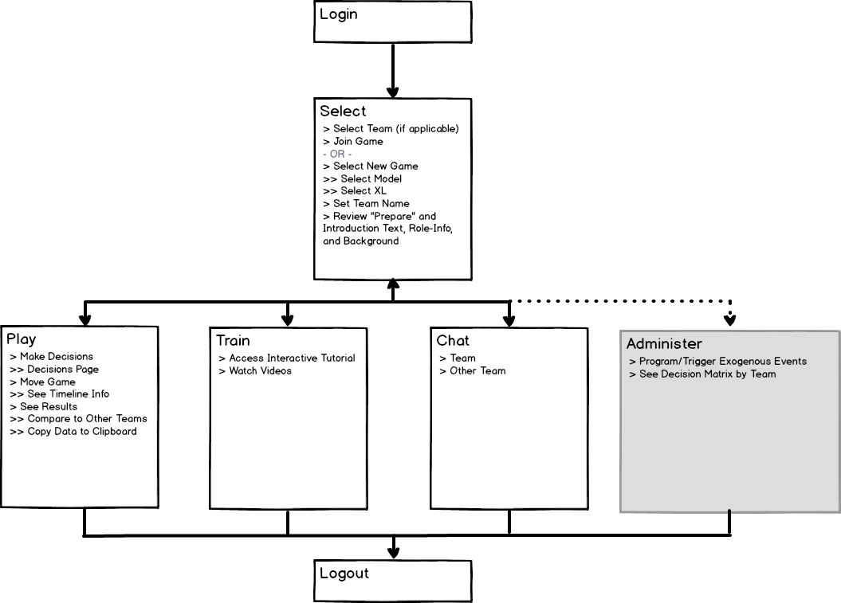

1. Login
2. Select
3. Play
4. Train
5. Chat
6. ~~Manage Profile (TBD, we may not need a separate Page or Page Group)~~
7. Administer

~~We expect Chat notification to be available through several pages. (Pls see Figure 1, Chat icons). How the chant content may be accessed (i.e., is chat a tie window, or a separate page) is still TBD.~~

The following Table describes the Pages (or Sections or Tiles) in each Page Group.

|  |  |  |
| --- | --- | --- |
| Page Group | Page / Section / Tile | Description / Requirements |
| Select | 1. Main | 1. User can join an existing game or start a new game. 2. Existing game → page shows model selected and calendar status (and XL file selected?) 3. New game → select model and XL file 4. Note: we still have to investigate how Forio handles game status, teams, groups, etc. |
| Select | 2. Welcome | 1. Introductory text 2. Basic info, including navigation info (click “Play” to …) 3. “Prepare” info |
|  |  |  |
| Play | 3. Model |  |
| Play | 4. Gameplay |  |
| Play | 5. Decisions |  |
| Play | 6. Outputs | 1. Graphs 2. Export (csv) 3. Compare Scenarios (and we need to determine what ARE scenarios) 4. Copy data to clipboard |
|  |  |  |
| Train | 7. Main | 1. Basic info and intro |
| Train | 8. Text-based help | 1. with expandable topics? |
| Train | 9. Video-based help | 1. Video-based help (phone: landscape) |
|  |  |  |
| Chat | 10. Team |  |
| Chat | 11. Other Team |  |
|  |  |  |
| Admin | 12. Team Decisions | 1. Decision matrix by team |
|  | 13. Exogenous Events |  |
|  |  |  |

## Wireframes

These are WIP (work-in-process)

1. Select  
   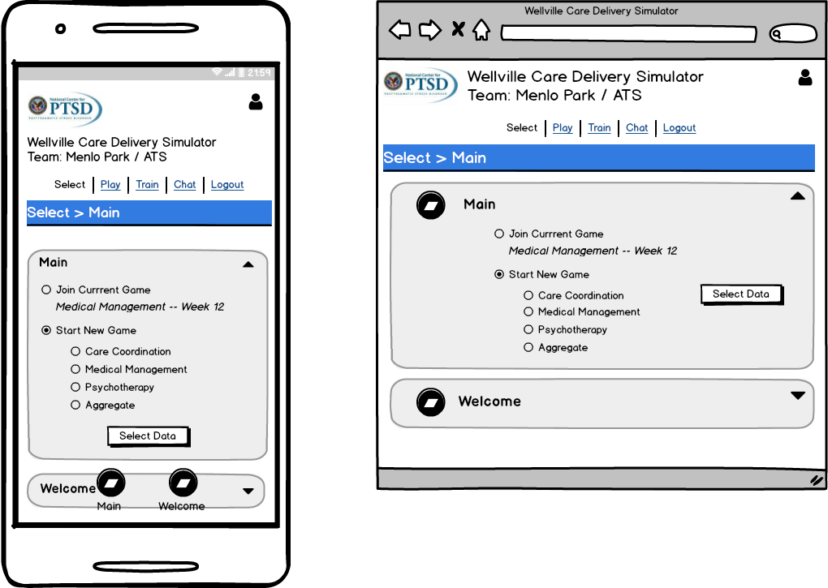
   1. XXX
2. Play

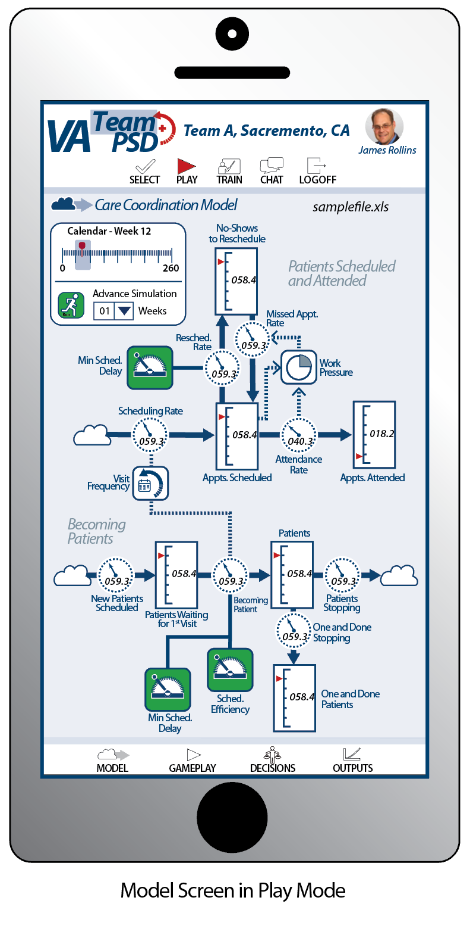 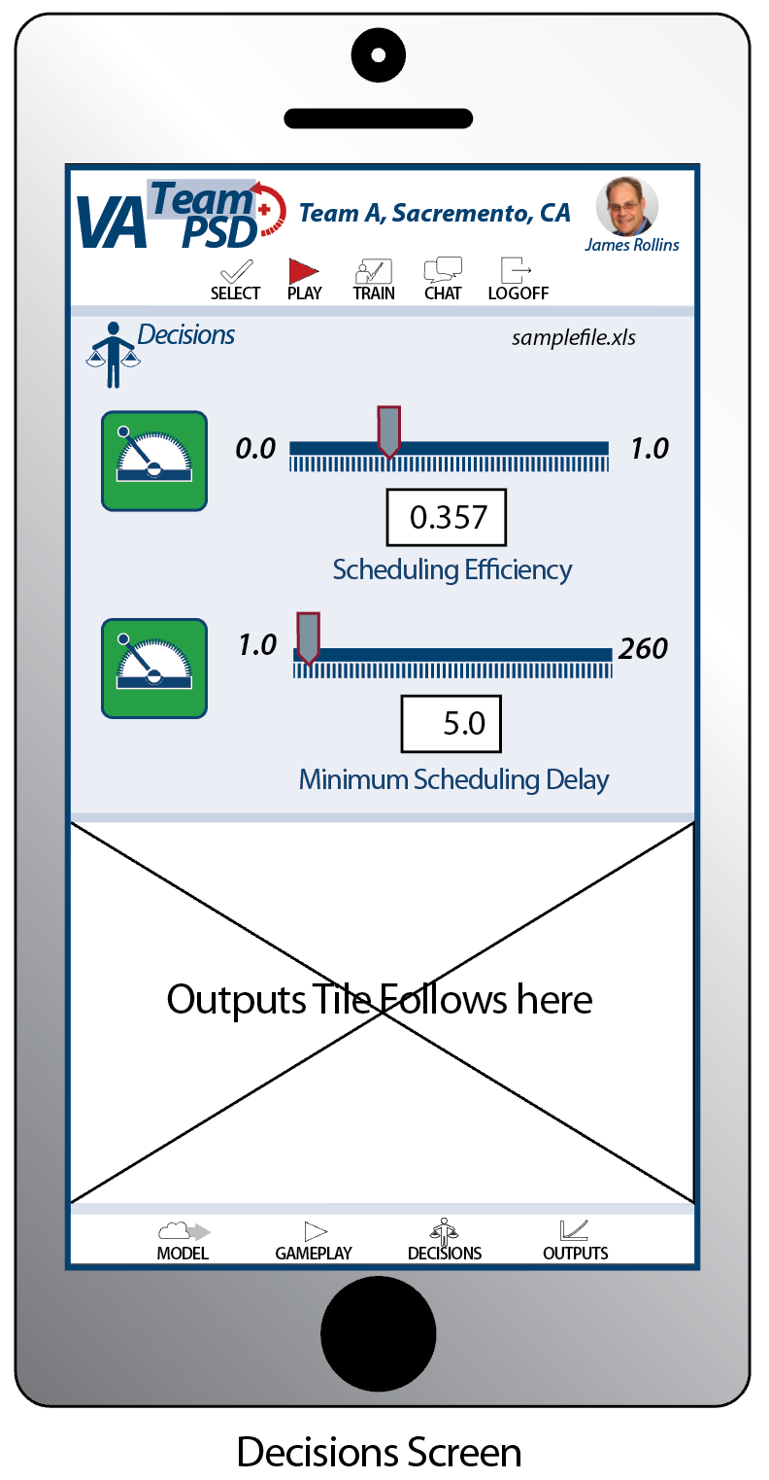

Play / Model Play / Decisions

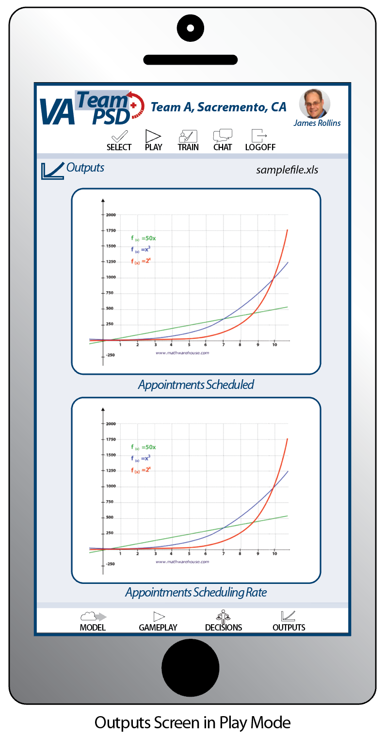 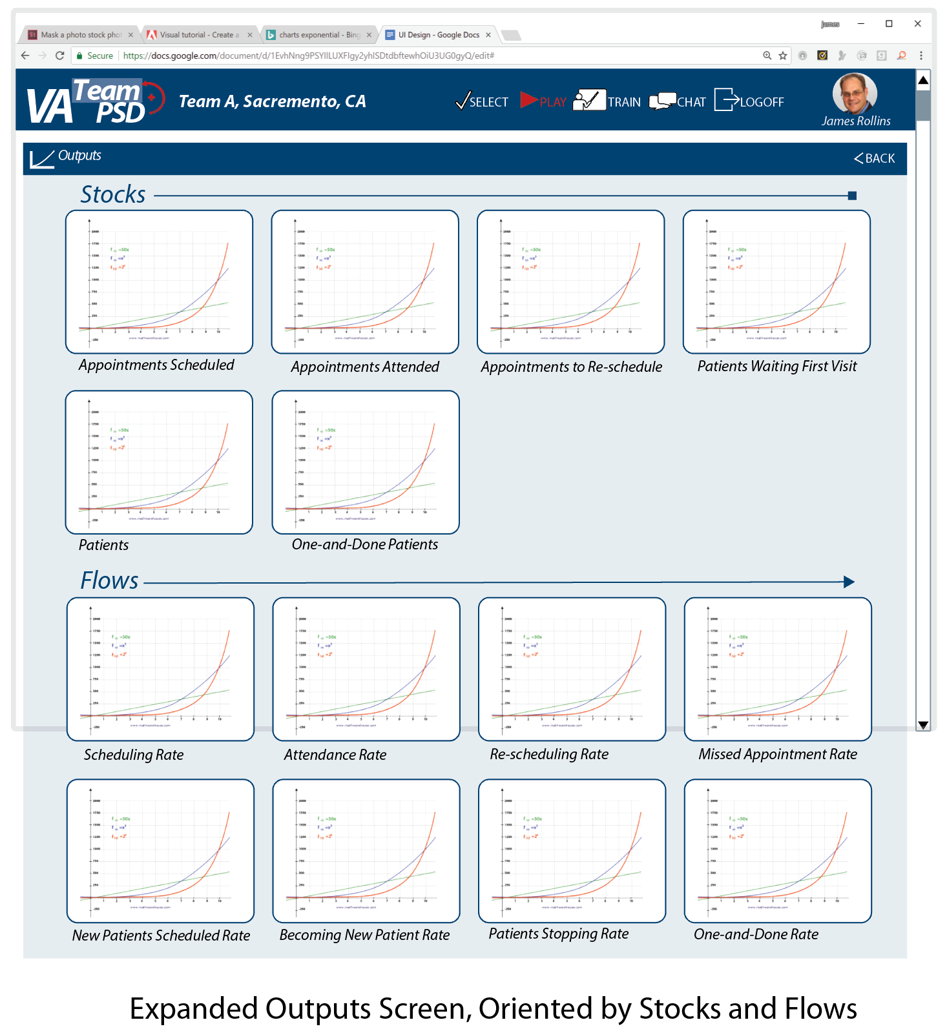

Play / Outputs

* 1. The tiles that are part of the Play pages are accessed through fixed bottom navigation
     1. Examples:
        1. <http://www.resoluut.com/showcases/red-dot-awards-2017/>
        2. <http://miyamotointernational.com/>
           1. “Carat” at LRH corner to navigate back home

1. Train



1. Chat

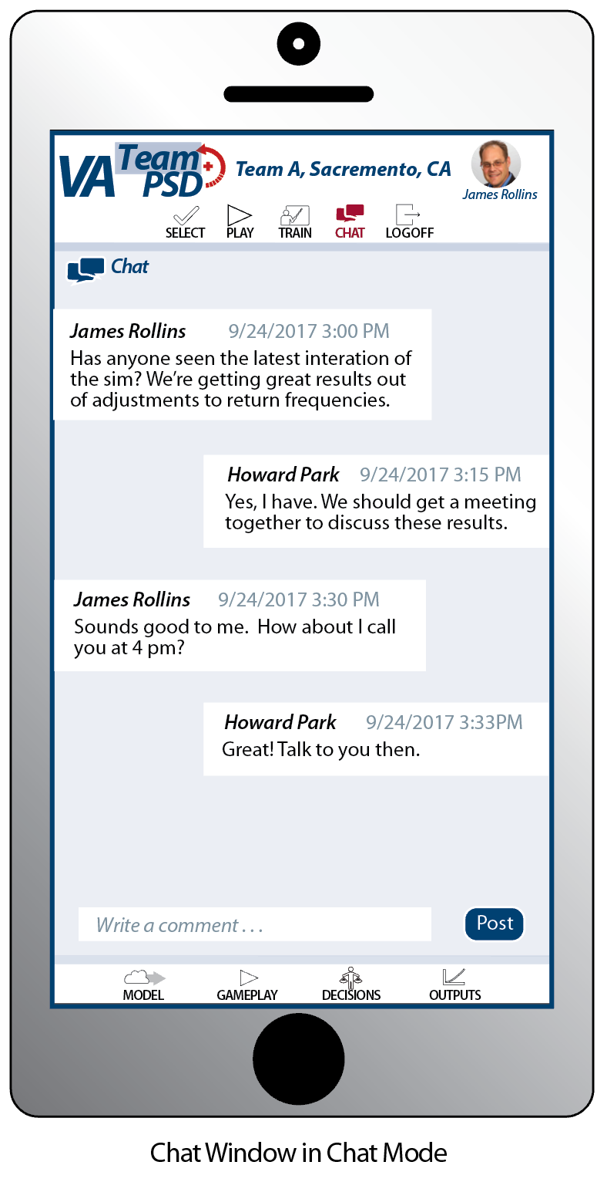

1. Admin  
   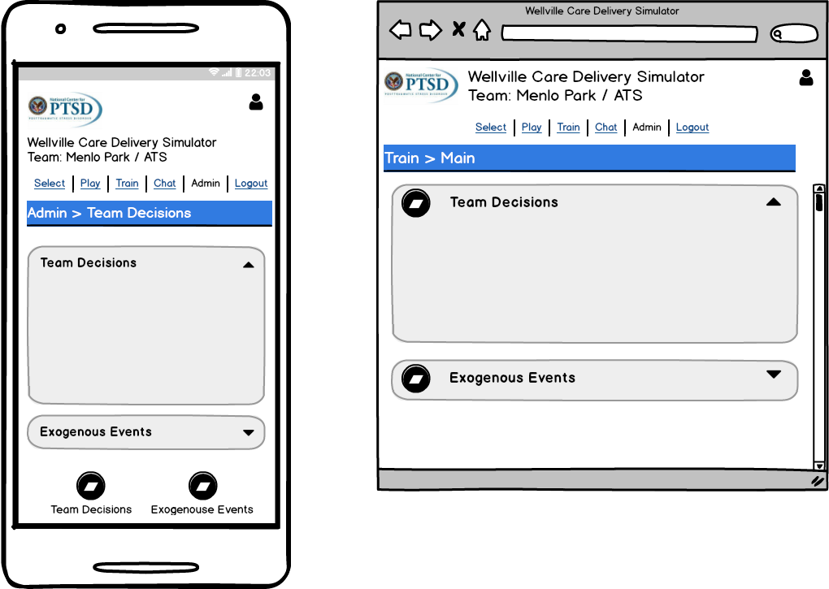
2. XXX

# SOW Requirements

This section describes the requirements as outlined in the SOW.

We list the requirements organized by WW’s SOW, then cross-listed to VA’s SOW (Statement of Work). More detail of the mapping of tasks can be found on “VA\_PSD\_Iterations\_Features\_HCP3.xlsx”.

The headings are in the format “WW Task / VA SOW”.

## 2.01 General Functionality / 5.1.1. General Login Page

1. For Iteration A, a simple login page will work
2. Include on the Login Page
   1. NC-PTSD logo (see Appendix)
   2. “VA PSD Simulation”
   3. “Iteration A”

## 2.03 Player’s Dashboard / 5.9.1 General Player Functionality

General Player Functionality is embedded in the design and requirements of the Pages described above (for example, ability to advance the model clock, make decisions, etc.).

## 2.03 Player’s Dashboard / 5.9.2 Introductory Screen with Role-information and Background

Select > Welcome

Text will be provided.

## 2.03 Player’s Dashboard / 5.9.3 Ability to upload team-member pictures

This is provided by the Forio Epicenter platform.

## 2.03 Player’s Dashboard / 5.9.5 Timeline information, tracking progress against schedule

Note: the following describes the design for Iteration A; there are expanded or more detailed requirements for Iteration B.

Play > Model

The simulation will show the current model time as indicated on the Pages described above.

~~[We are getting clarification on “tracking progress against schedule”]~~

## 2.03 Player’s Dashboard / 5.9.6 Dashboard with access to key metrics

Note: the following describes the design for Iteration A; there are expanded or more detailed requirements for Iteration B.

Play > Outputs

The simulation will show a series of output metrics as indicated on the Pages described above.

## 2.03 Player’s Dashboard / 5.9.10 Decisions Page

Note: the following describes the design for Iteration A; there are expanded or more detailed requirements for Iteration B.

Play > Decisions

The simulation will show a series of input decisions as indicated on the Pages described above.

## 2.03 Player’s Dashboard / 5.10.1 Introduction & Help: Text-based 'prepare' section

Note: the following describes the design for Iteration A; there are expanded or more detailed requirements for Iteration C.

Select > Welcome

Text will be provided.

## 2.03 Player’s Dashboard / 5.10.2 Introduction & Help: Text-based 'help' section

Note: the following describes the design for Iteration A; there are expanded or more detailed requirements for Iteration C.

Train > Text-based help

Text will be provided.

## 2.03 Player’s Dashboard / 5.10.3 Integrate tutorial videos

Note: the following describes the design for Iteration A; there are expanded or more detailed requirements for Iteration C.

Train > Video-based help

For iteration A, we can use the following on-line videos to embed as examples:

* Introduction to PSD Demonstration  
  <https://www.youtube.com/watch?v=HODHH5-vemw>

On which screen embed on UI? [See above]

## 2.08 Managing/Facilitating Simulations / 5.6.1 Open/Close Access to Simulation

Provided by Forio Epicenter.

# General Requirements

This section describes requirements that support the SOW Requirements, but may not be tied to a specific SOW section.

## Managing Multiple Vensim Models

1. We expect to have four separate Vensim Models as part of the Forio UI Platform. The four models (by name/description, and not by filename) are:
   1. Care Coordination (CC)
   2. Medical Management (MM)
   3. Psychotherapy (Psy)
   4. Aggregate (Agg)
2. We discussed (on Fri 25-Aug with Forio) 3 options for deploying 4 separate Vensim Files. **We decided that Option A would work for us.**

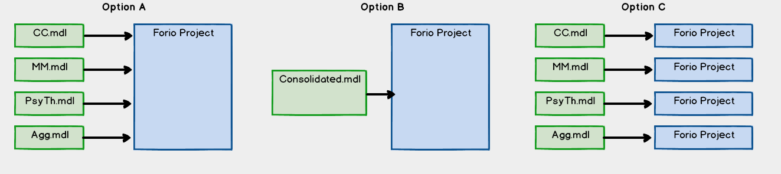

* 1. Option A -- We decided to go with Option A
     1. This will work if:
        1. We do not need more than one model being accessed per Team at a time. This includes on-going games. A game/world/session can only be accessing one model at a time.
        2. We do not need to access variables nor logic across the models.
     2. We will need to resolve how the appropriate model (and the appropriate csv file data) is/are loaded for a team’s game/world.
  2. Option B
     1. This is preferred (and is the “default” configuration); however, we think the four Vensim models will be finished at different times.
  3. Option C
     1. This could work, but it requires more Forio Projects (URLS, etc.) than planned, and also places a lot of burden on the users and admin to track URLs, userid/passwords, etc.

## Managing XL files

1. For a team, we will have one or more XL file(s), with each XL file having four sheets (tabs), with each sheet having data that can be imported into one of the four Vensim models. The Vensim models provided will already have the variables (Vensim Auxiliaries) that can be matched with the XL data.
2. UI and user implications: we need to make it easy to call up the correct data for the Team/Model combination.
3. Epicenter reference: https://forio.com/epicenter/docs/public/model\_code/vensim/vensim\_example\_xls/

# Appendix

1. NC-PTSD logo (from Lucid Meetings)  
   
2. XXX`